Buletinul Ştiinţific al Universităţii "POLITEHNICA" din Timişoara
Seria HIDROTEHNICA
TRANSACTIONS on HYDROTECHNICS

Tom 55(69), Fascicola 2, 2010
Water resources
Dumitran Mihaela¹

Abstract: The paper examines the field of water quality and water management, the main objectives of action and guidelines for the protection of water resources for sustainable development. Problems are analyzed in the context of water resources Integrated Water Resources Management, which ensures the coordinated development and management of water without compromising the sustainability of vital environmental systems.
Keywords: water resources, water integration, sustainable use, water management

1. INTRODUCTION

The concept of sustainable development was established in response to the emergence of environmental and natural resources. Basically the Stockholm Environment Conference in 1972 when it recognition that human activities contribute to environmental damage, putting the risk future of the planet.
In 1983, he began work for the World Commission on Environment and Development (WCED), by a resolution adopted by the (UNO) United Nations General Assembly. The term sustainable development has started to become, however, well known until after the Conference on Environment and Development, organized by the United Nations in Rio in the summer of 1992, known as "the Earth Summit." It resulted in the development of several conventions on climate change, biological diversity and stopping deforestation. Everything then was developed and Agenda 21 - plan to support sustainable development.
Management, development and use of water in a truly integrated manner are a premise for achieving the Development Millennium Goals. UNO Conference on Water and Development in Dublin in January 1992 to bases the four "Dublin principles": (1) holistic principle, (2) the participatory principle, (3) the principle of gender (4) economic principle that form a "mindset" for development and management of water resources. [1]
In Romania, especially due to the functionality and multiple uses of water, the inconsistency between time and space distribution of water resources and that the requirements, and due to the phenomenon of re-using water along watercourses, emerged as particularly the necessary coordination of management and utilization of water resources. It periodically update framework planning schemes and water management on river basins in order to establish fundamental orientations on sustainable management.

1.1 THE CURRENT CONCEPT OF WATER RESOURCES MANAGEMENT.

Since 2001 have begun to form partnerships and Freedoms of Water-CWP in member countries of the region, that in Slovakia, Czech Republic, Slovenia, Hungary, Bulgaria, Romania - Danube-Black Sea area and Poland, Estonia, Latvia and Lithuania in the Sea Baltic, they actually constitute the Regional Partnership GWP-CEE.

Table1. The specific consumption of water in different states"(m³/year*habitant)
Bulgaria | 1240
Portugal | 1100
Romania | 1001
Spain | 840
Italia | 780
Ukraine | 750
Hungarian | 720
Greece | 700
France | 680
Germany | 580
Albania | 575
Island | 535
Rep. Moldova | 520
Russia | 515
Holand | 500
Norwei | 495
Finland | 493
Poland | 420
Switzerland | 395
Sweeden | 360
Ireland | 300
Belarus | 295,5
Austria | 280
Czech Republic | 230
Denmark | 225
Great Britain | 185
Estonia | 125

Water quality was characterized at the river basin, based on the quality of natural and human impacts. Among 1976-2004 worked NSCC (National System for Monitoring Water Quality) which included five subsystems. NSCC since 2005 has been improved, taking into account the specific requirements of the EU Water Framework Directive 2000/60. In Romania took place specific activities of the TAC during the meeting with a number of constituents, the production of specific documents, such as: VISION-2025 - development at national and regional levels to the water sector in 2025.
Comparing data of water consumption in Romania with those of other European countries, it appears that, although it is one of the poorest countries in water resources, water consumption per capita of Romania is one of highest in Europe beyond the consumption of more developed countries economically

2. IWRM IMPLEMENTATION

Considering the water resources of exogenous (which represents the contribution of rivers that are formed in other countries and then enters the country) in the Romanian Danube and waterways in the basin of the Siret higher - 170 km ³ / year, total resources of Romania's water amounts to 212 km ³ / year. Therefore, Romania depends very largely on water resources coming from different countries upstream. Based on these findings, the layout of the proposed use of water resources particularly the Danube, which would come right on exogenous resources for subsequent negotiations with other riparian countries Freshwater resources, the reality figures across the globe - only 0.009% Romania has relatively low water resources is to place nine of the 25 Member States. Towards the European average of 4000m3/loc./an, Romania, the volume is usable water resources from 2600 to 1770 m3/habitant./year from surface waters. Water quality in Romania is followed according to the structure and methodological principles of Water Integrated Monitoring System in Romania (SMIAR), restructured in accordance with the requirements of European Directives. Romania - Condition surface water quality .Overall quality of surface water flowing (an analysis on 78,905 km, which is the total number of coded watercourses Romania)

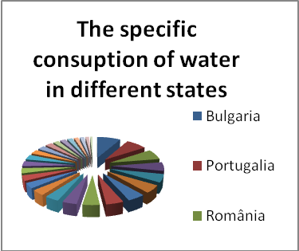
Fig. 1 The specific consumption of water in different states (m³/year*habitant)
Class I - 23.8%; Class II - 45%; Class III - 18.8%; Class IV - 7.9%; Class V - 4.5%
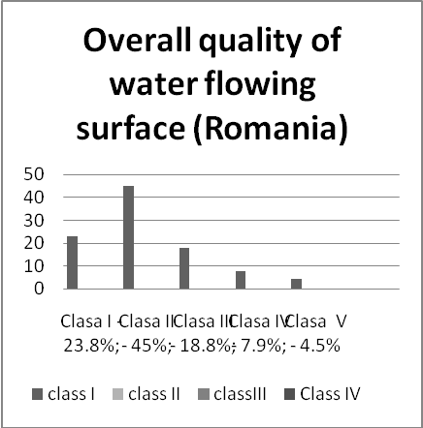
Fig.2. Overall quality of water flowing surface (Romania)

Table 2 Water resources in Romania
Water resources | Billion theoretical cubic meters | Billion cubic meters of water resources used
River | 40 | 14,14
Danube | 85 | 20
Groundwater | 10,3 | 5,998
Total | 134 | 61

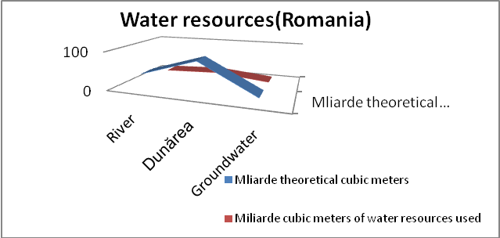

Fig.3. Water resources

3. MANAGEMENT OF THE WATER QUALITY UNDER EUROPEAN UNION
Modernization and development of water quality monitoring system. According to the Framework Directive, and other European water policy directive requires monitoring of water quality over the existing sub-systems including new and redefining the existent. Framework Directive states that "all bodies of surface water in the river basin district must be
identified as part of the following categories: rivers, lakes, transitional waters or coastal marine waters, as surface water bodies or heavily modified water bodies. (Annex II 1.1 (I) of the WFD).
Operating workbook in Romania under the monitoring system, the water area of the Prut River Basin Administration-Barlad are monitored following sub-systems:

Table 3 Monitoring System on the Prut River Basin
Sub-surface rivers | Stability control section 32 due to boundary water bodies (S, O)
Sub-surface rivers | 4 sections of reference (R)
Sub-surface rivers | 5 sections CBSD – sections best available
Sub-surface rivers | 8 sections of the border (CI)
Sub-surface rivers | 3 section TNMN network (Transitional Monitoring Network)
Sub-surface rivers | 8 section EIONET (European Environmental Information and Observation Network)
Sub-surface rivers | 3 sections in fast flow (day, week)

In Romania the representative bodies have proposed monitoring sections, the average investigation and monitoring programs for understanding the status and trend of the water body and when environmental objectives. According to qualitative characteristics of water bodies were conducted monitoring programs specific to each section, in accordance with the operating manual of the monitoring system: surveillance program (S) OP (O) investigation program (I ) The reference (R) program "the best
available section (CBSD), intercalibration program (JI), potable Program (P) Monitoring Program for vulnerable zones (ZV) monitoring program for ichthyofauna (HI), Habitats and Species Protection Program (HS), Program for International Convention (IC) program impact hydro morphological alterations (CAPM). These programs are consistent with the requirements of the European Council Framework Directive and the River Prut. Prut monitoring and surveillance in the section table.

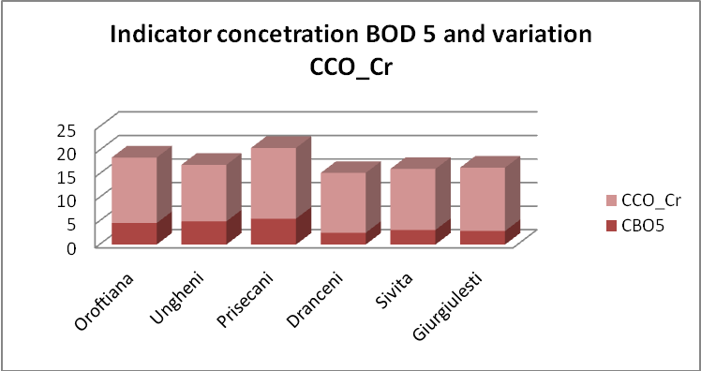
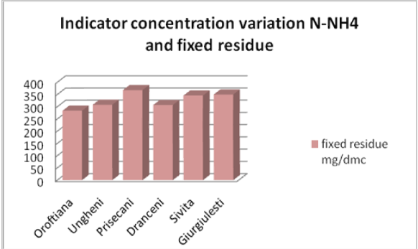
Prut water is classified as class II quality

Table 2.Natural concentration for certain parameters untouched river in conditions
Parameter | Minimum (mg/l) | Maximum (mg/l)
SiO₂ | 2.4 | 20
Ca⁺² | 2.0 | 50
Mg⁺² | 0.85 | 12.1
a⁺ | 8 | 25,3
K⁺ | 0,5 | 4
Cl⁻ | 0,6 | 25
SO₄⁻² | 2,2 | 58
HCO₃⁻ | 10 | 170
pH | 6.2 | 8.2
Suspension solid totaled (TSS) | 10 | 1700
Dissolved organic carbon(COD) | 2.5 | 8.5
N-NH₄⁺ (mol) | 0.005(0.007) | 0.04(0.05)
N-organic(mol) | 0.05 | 1.0
P-PO₄ | 0.002(0.006) | 0.025(0.075)

For priority substances, the WFD require limits to be drawn on the ecotoxicological ordinance were adopted limits to Romanian law. The results of their computations show that the new standards are
Romania in some cases more stringent than the equivalent of the current directives and standards that will lead an apparent reduction in the number of section that can reach good quality water

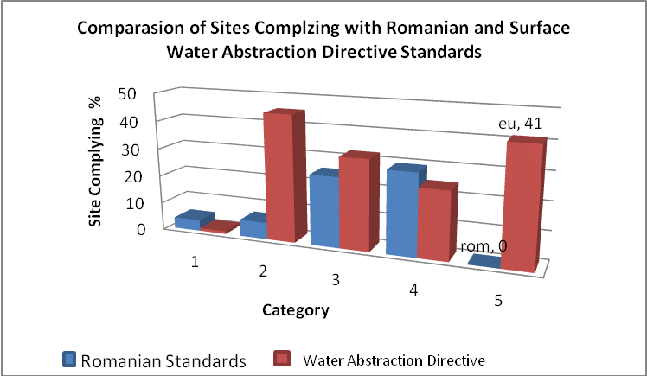
Fig.4. Comparison sections on surface water capture and Romanian standards
4. CONCLUSIONS
Integrate management of water resources is a complex process. EU wants implementation of sustainable development and integrated management of water resources across Europe. Protection of water resources, water resources conservation in 1991 and requires increasing responsibilities of ministries and national authorities of the river, in terms of nature protection, flora, fauna, sustainable use of water from one river basin, development must based on the community, basicservices refers to the right to life, "One for all" instead of "all for one", the allocation and equitable regional development resources, water has an economic value, users are charged for water use , integrated development, maintaining environmental integrity[2].

5.REFERENCES
[1] Giurma I et. al - Water resources management, 2000, Ed. Cermi, Iasi
[2] Giurma I. et. al – Integrated Water Resources Management, Performance Publishing,2010
[3] Gheorghe Cretu - Optimizing water management, Ed Facla, 1980
[4] Torkil Jønch-Clausen "...Integrated Water Resources Management (IWRM) and Water Efficiency Plans by 2005" January 2004,GWP (Global Water Partenership)
[5] JUDITH A. REES, JAMES WIN PENNY et. al Water Financing and Governance ,Global Water Partnership Technical Committee (TEC), www.gwpforum.org
[6] *** Cap-Net plantsIWRM: Training module, March 2005, [Online] www.cap-net.org
[7] Peter Rogers, Ramesh Bhatia and Annette Huber, “Water as a Social and Economic Good: how to Put the Principle into Practice” ,1998, GWP
[8] Malin Falkenmark -“Water Management and Ecosystems: Living with Change” , GWP, 2003
[9] Varduca A, Popescu L. - Report on the Water pollution including Accidental Water pollution in Romania, 2006
[10] Clarendon Smith, K- Innovation as a systemic phenomenon: Rethinking the role of policy. Enterprise and Innovation Management Studies 1.1: 73–102, 2000, GWP
[11] Miguel Solanes and Fernando Gonzales Villarreal- “The Dublin Principles for Water as Reflected in a Comparative Assessment of Institutional and Legal Arrangements for Integrated Water Resources Management”,1999, GWP
[12] Judith A. Rees - “Risk and Integrated Water Resources Management” , GWP ,(TEC)2002
[13] Peter Rogers and Alan W Hall - “Effective Water Governance” , GWP,2003
[14] Varduca A - Daily Based Water problems, GWP- Romania, 2006
[15] ” Malin Falkenmark- “Water Management and Ecosystems: Living with Change, GWP(TEC- Technical Advisory Committee),2003
[16] Falkenmark, M. 1997. Society’ s interaction with the water cycle: A conceptual framework for a more holistic approach. Hydrological Sciences , 42: 451–466.
[17] Eagleson, P.E. and Segarra, R.I., Water-limited equilibrium of savanna vegeation systems. Water Resources Research , 10: 1483–1493, 1985
[18] Akiça Bahri- Managing the other side of the water cycle: Making wastewater an asset Global Water Partnership Technical Committee (TEC)
[19] Harremöes P. 1997. Integrated water and waste management. Wat. Sci. Tech.,
35(9), 11-20
[20] Asano T. 2002. "Water from (waste)water – The dependable water resource", Water Science & Technology 45/8 (2002) 23–33.
[21] Jiménez B. and A. Chavez. - Quality assessment of an aquifer recharged with wastewater for its potential use as drinking source: “El Mezquital case” case. Water Science and Technology 50 (2): 269-273, IWMI (International Water Management Institute). 2006

