REGISTRATION FORM

Name……………………………………
Surname…………………………………
Institution/Firm…………………………
………………………………………….
………………………………………….
(Street, Mail code, City, Country, Phone/Fax)

Wish to be registrated at:

❑ Delegate
- Author (enclosing title/titles of paper/papers)
❑ Exhibitor (enclosing the necessary
space and content of exhibits)

In accompany :
…………………………………………
…………………………………………

I wish accommodation:

❑ room with 2 beds (in common)
❑ room with 1bed

for:

16/17 17/18 18/19
❑  

Date Signature
Please fill in the registration form with capital letters and send it to the organizing committee until 17 March 2008, at the following address:

Faculty of Civil Engineering
Building Installations Department

Str. Traian Lalescu Nr.2A
România 300223 Timişoara

or fax:
+40-(0)256-404010
+40-(0)256-200368
+40-(0)256-403987
or E-mail:

secretariat.instal@ct.upt.ro
ionitasilviu@dosetimpex.ro
remus.retezan@direm.ro

For further specifications concerning your participation please use the counter page of the registration form.

For further information please use the phone number:

+40-(0)256-403991 +40-(0)256-295230
+40-(0)256-200368

or one of the fax numbers:
+40-(0)256-404010
+40-(0)256-200368
+40-(0)256-403987

A.I.I.R. ROMANIAN ASSOCIATION OF INSTALLATIONS ENGINEERS
Banat Branches, Timisoara

“POLITEHNICA” UNIVERSITY OF TIMIŞOARA
FACULTY OF CIVIL ENGINEERING

BUILDING INSTALLATIONS DEPARTMENT

Timisoara Branches of

SORPINC,SOROPA, SIEAR, AGFR

CENTRAL EUROPEAN ACADEMY
OF SCIENCE AND ART

CCIC – Research Center for Building Installations

“Danube” ASHRAE Chapter

REHVA – Federation of European Heating and

Air Conditioning Associations

ARTECNO SRL Bucureşti

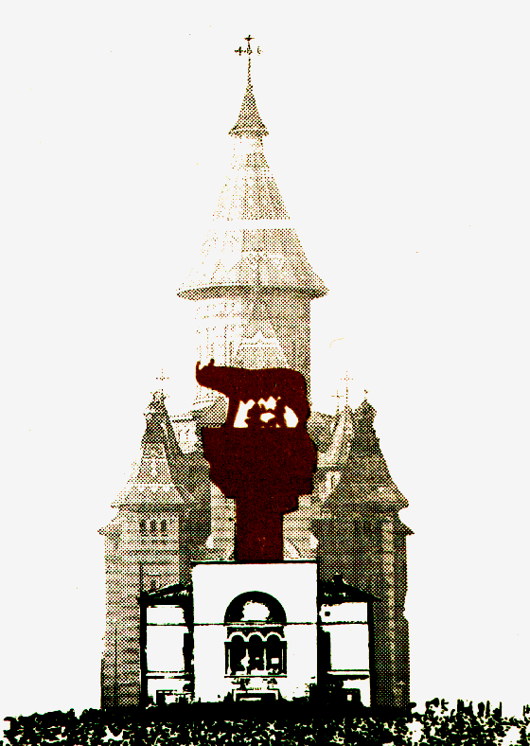

CONFERENCE

INSTALLATION FOR BUILDING AND THE AMBIENTAL COMFORT

XVI - th Edition
with international participation
TIMISOARA - ROMANIA
17 - 18 April 2008

Organizers of the Conference

INSTALLATION FOR BUILDING
AND
THE AMBIENTAL COMFORT

have honor to invite you as author, exhibitor or delegate, to the conference, that will take place from 17th to 18th April 2008

This conference offers you the possibility for exchanges of opinion and information concerning:
- ambient comfort
- environmental protection
- EPDB – Energy Performance of Building Directive
- technical and economical parameters of the installations
- problems of optimized sizing and functionally improvement manners for installations
- improper installation functioning effects on man’s health
- materials, equipment’s and manufacturing technologies for building installation
- management problems
- aspects of the Romanian building installation school

An exhibition for equipments, apparatus and materials used in building installations is organized as part of the conference

TIMIŞOARA IS WAITNG FOR YOU!

PRELIMINARY INFORMATIONS
- Official opening will take place on Thursday 17th April 2008 at 9³⁰ in the “Constantin Avram” amphitheater of the Civil Engineering Faculty.( 2A Traian Lalescu street, Timisoara)
- The program include:
- presentation of generally papers and discussions
- debates upon the problems
- presentation of the exhibition firms
- ASRAE “Danube” Chapter Meeting
- Close of the meeting, on Friday the 18th April 2008 at 18³⁰
For realizing the volume of the Conference, please send your paper (electronic form), edited as the enclosed model till 17th March 2008 at e-mail address
editura@edipol.upt.ro
claudia_mihali@yahoo.com
secretariat.instal@ct.upt.ro
During the meeting the followings are provided:
- participation to the Conference and exhibition
- volume and program of the Conference
- refreshments
- lunch, dinner ( paid ).
Participation fees:
- for authors/person: 150 €
- for accompanying persons: 100 €
- for delegates 200 €
- students 50 €
Room reservation for participants is assured at the hotel only by request, accommodation will be supported by the participants.
The organizers ask to respect the upper mentioned dates in order to have the possibility of including you as a participant.
Further specifications:

TITLE OF PAPER
(Times New Roman 14pt. Bold Centered)
author/authors; institution
(Times New Roman 12pt. Bold Centered)
(Times New Roman 12pt.)
1,5cm
6 cm
2,5cm
2,5cm
2,5cm
Summary
(Times New Roman 12pt. italic)
2cm
Text at 1 ½ space
The next pages begins at 2,5 cm from top
2,5 cm
The last page will have ½ pg. free for Romanian Summary
(this will be assured by organizers).
The paper can have 4 - 8 pages.
The paper will be edited in Word processor.

